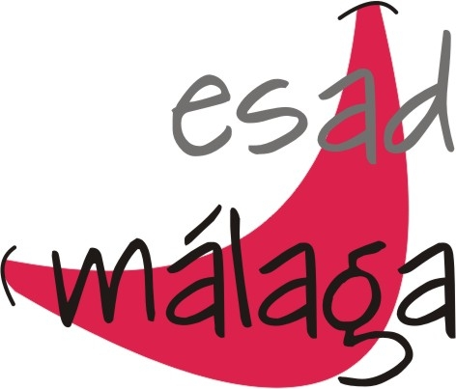

Erasmus Student Traineeship in Spain

EMPLOYER INFORMATION
Name of organisation | Escuela Superior de Arte Dramático de Málaga (ESAD MÁLAGA)
Address inc post code | Calle Bela Bartok. 2.  29010. Málaga. (Spain)
Telephone | 00 34 951 29 83 79
Fax | 00 34 951 29 36 95
E-mail | info@esadmalaga.com
Website | www.esadmalaga.com
Number of employees | 50
Short description of thecompany | ESAD MALAGA is an institution of higher education specializing in theatrical education
CONTACT DETAILS
Contact person for this placement | Pablo García Martínez
Department and designation, job title | International Relations / Head of Department
Direct telephone number | 00 34 951 29 83 80
E-mail address | internacional@esadmalaga.com
APPLICATION PROCEDURE
Who to apply to (including contact details) | Pablo García Martínez  internacional@esadmalaga.com
Deadline for applications | Autumn term: 15th October  Spring term: 15th February
Application process | Please send your CV and letter of motivation (state your prefered dates of beginning and ending of the internship) per e-mail to:  internacional@esadmalaga.com
PLACEMENT INFORMATION
Department, Function | Library. Librarian.  ESAD Library is a service for the school community. Its aim is to facilitate access to library collections that the institution provides, to control the system of loans and to offer a place for study and research.
Location | ESAD Building. Calle Béla Bartók.2. Málaga (Spain)
Start Date | Start Autumn: 1st November  Start Spring: 1th March
Duration | Four months
Working hours per week | Full-Time. About 25 hours per week. Working hours on agreement.
Description of activities,tasks | - Updating online database.  - Updating homepage.  - Preparation and checking of documents (related to book lending).  - To guide students in finding library collections.  - Save used books.
Accommodation | ESAD does NOT provide housing.
Details of financial and “in kind” support to be provided
Other
COMPETENCES, SKILLS and EXPERIENCE REQUIREMENTS
Languages and level of competence required | Good command of Spanish (equivalent to level B2 or above).
Computer skills and level of skills required | Computer literate – Microsoft packages.
Drivers license | Not needed.
Other | A quick learner who is accurate and reliable.

