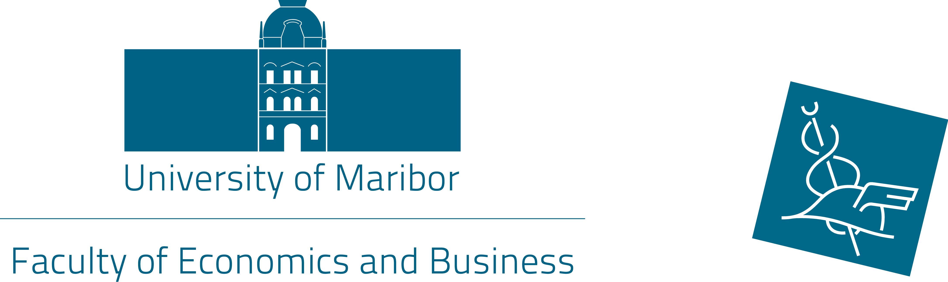
UNIVERSITY OF MARIBOR
Faculty of Economics and Busines
Razlagova 14, 2000 Maribor
International Office

ERASMUS+ TRAINING in Maribor
„…let´s gain dynamic and positive experiences…“

Practical placement: Faculty of Economics and Business - International Office

Short description of main tasks: - collaborating with the foreign partners universities, institutions
- administrative and other tasks considering on students outgoing and incoming mobility,
- activities in some international projects

Duration of training: 6 months

Beginning of training: Beginning on 1st October 2016 till 31st March 2017

Conditions of payment: - Erasmus or other scholarship from home institution

- Award from Maribor University Faculty of Economics and Business

Requirements: - CV with photo to e-mail feb.international@um.si,
- well proficient in English
- well proficient in computers programe (Word, Excell,..)
- communicative and open minded person
- field of study is not important

What do we offer: - all students benefits (food coupons, dormitory, library),
- work in pleasant international environment
- lively and young atmosphere in city of Maribor

Contact: International Office
Sanja Kocijan, MSc.
Tel: +386 2 22 90 252
E-mail: sanja.kocijan@um.si or feb.international@um.si

Deadline for application : 30 June 2016

