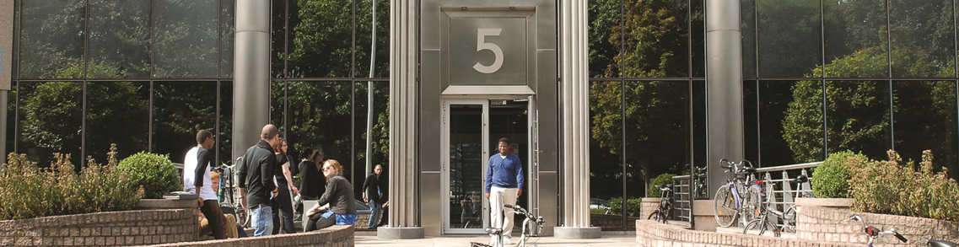



**Traineeship at the Brussels Diplomatic Academy**

Length: 6 months

Location: Vrije Universiteit Brussel (VUB), International Relations and Mobility Office, Pleinlaan 5, 1050 Brussels

Description of the traineeship

We are looking for a trainee to join us to support the postgraduate programmes of the Brussels Diplomatic Academy. The traineeship involves working with a small team, embedded in the large international team of the International Office of VUB. Tasks include administration and logistics for several postgraduate programmes as well as contributing to the development of recruitment ideas and materials.

The traineeship is suitable for graduates from any discipline, and would be of particular benefit to someone wishing to work in education, international mobility, or communications and marketing. The tasks and mentoring of the traineeship cover those three areas.

The tasks include

* Room bookings and timetable management for the postgraduate programmes.
* Administrative and logistical assistance with the meetings and events of the postgraduate programmes and executive trainings.
* Contributing to marketing materials – design of new materials, provision of content for existing materials (website, mailing materials…), proof reading, layout checking.
* Development of recruitment ideas.

Candidate profile

The trainee must be part of the Erasmus + traineeship programme, and be undertaking the traineeship post-graduation.

The trainee must be proficient in written and spoken English.

Practical

Deadline for applications: 1st of June 2016

Tentative starting date: 25th of August 2016

Send applications, including covering letter and CV, to cailin.mackenzie@vub.ac.be